4K VPC Thermal Life Detector

Operation Manual

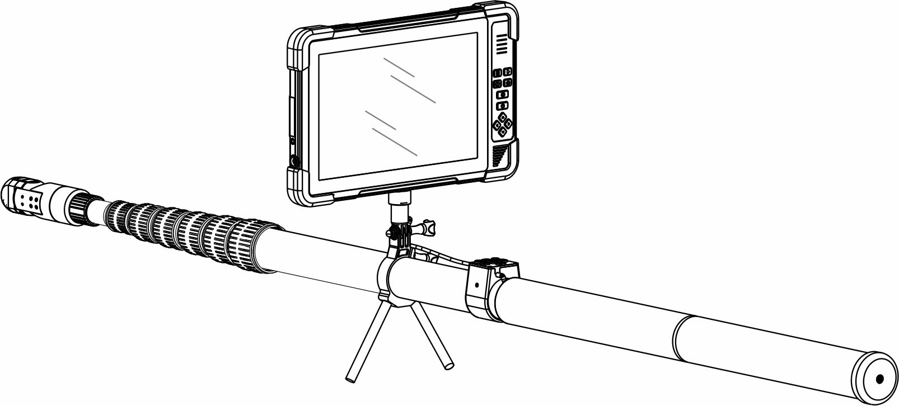

Menu

Product Overview …………………………………………………………3
4K Tablet Monitor……………………………………………….…………4-5
360° Intercom Camera(Optional)…………….……………………6
Hose Intercom Camera(Optional)…………………………………7
Infrared Thermal Imaging Camera(Optional)…………………8
Carbon Fiber Rod..………………………………………………………9
Installation & Use..………………………………………………………10
Button Operation..……………………………….……………………11-12
Screen Touch……………………..………………..……………………13-15
System Setting…………..…………………………………….………16-17
RoadCam App …………………………………………………………18
APP Monitoring Interface…….………………………….……….19
Charge/ Firmware upgrade/Attention…..…………………..20
Specifications……………………………………………………………21-23
RoadCam App Download…………………..……...……………….23

Product Overview

This 4K life detector can take up to 4K videos and 12 MP photos. Functions of photographing, recording and controlling, like 360 ° camera rotation, can be completed through screen touch, buttons both on monitor & rod. This detector uses a 10.1 HD touch screen, a 5 megapixels 360° intercom camera (optional), a 5 megapixels hose intercom camera(optional), an infrared thermal imaging camera(optional ) and a telescopic carbon fiber rod combination. Multiple combinations, simple assembly, convenient carrying, widely applicable to life rescue, disaster rescue, anti-terrorism and explosion-proof, scientific investigation and other fields.

4K Tablet Monitor

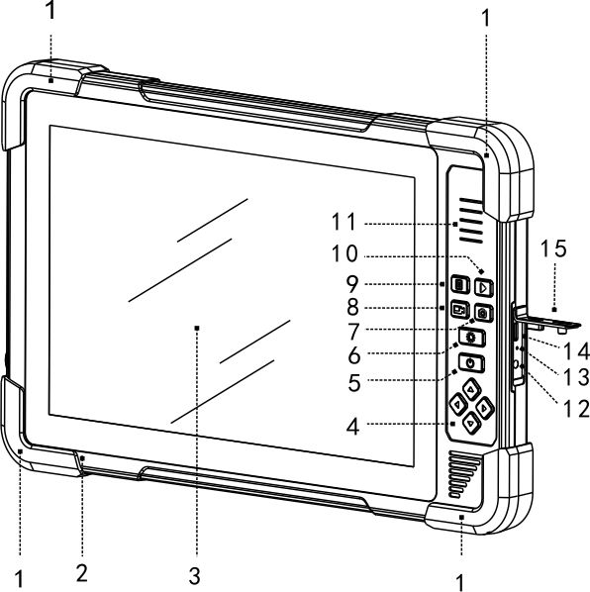

1.Protection corner
2.Microphone 9.Menu/Confirm
3.10 inch screen 10.Play/Return
4.Up Down Left Righ 11.Speaker
5.ON-OFF 12.DC12V
6.LED Control 13.Charge LED
7.Photo 14.TYPE-C
8.Record 15.Protective cover 1
4K Tablet Monitor

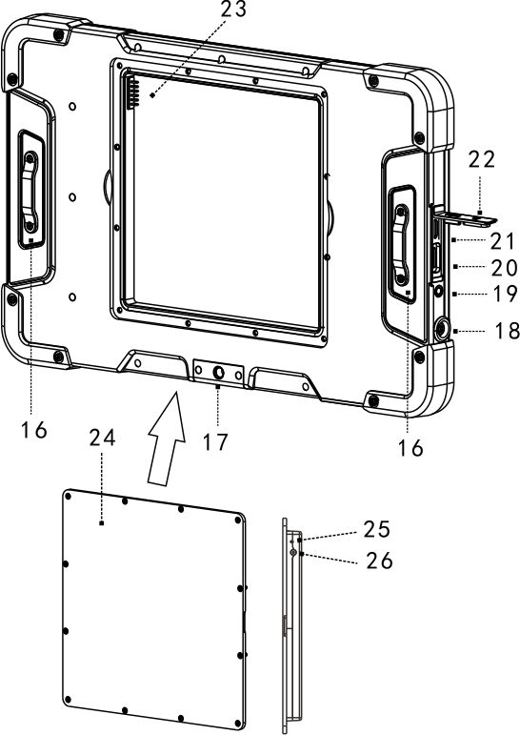

16.Rope buckle 22.Protective cover 2
17.1/4 inch screw 23. Battery Connector
18.Cam Connector 24.Battery box
19.Headset 25.Charging indicator
20.Micro SD Card 26. Battery box DC12V
21.HDMI Output

360° Audio & Video Camera （Optional）

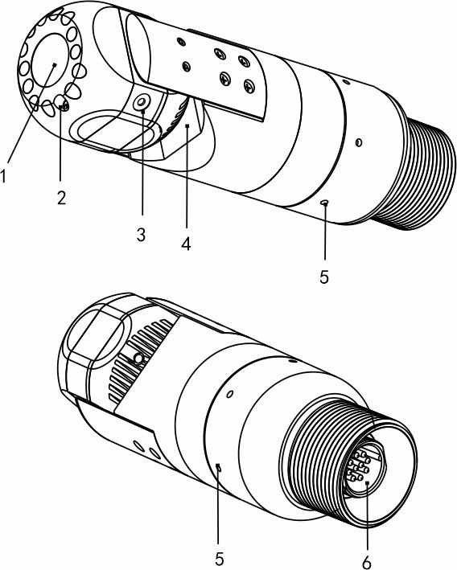

1, Lens 2, 12 LEDs
3, Microphone 4, Speaker
5， Clean Hole 6， Connector

Audio and Video Camera (Optional)

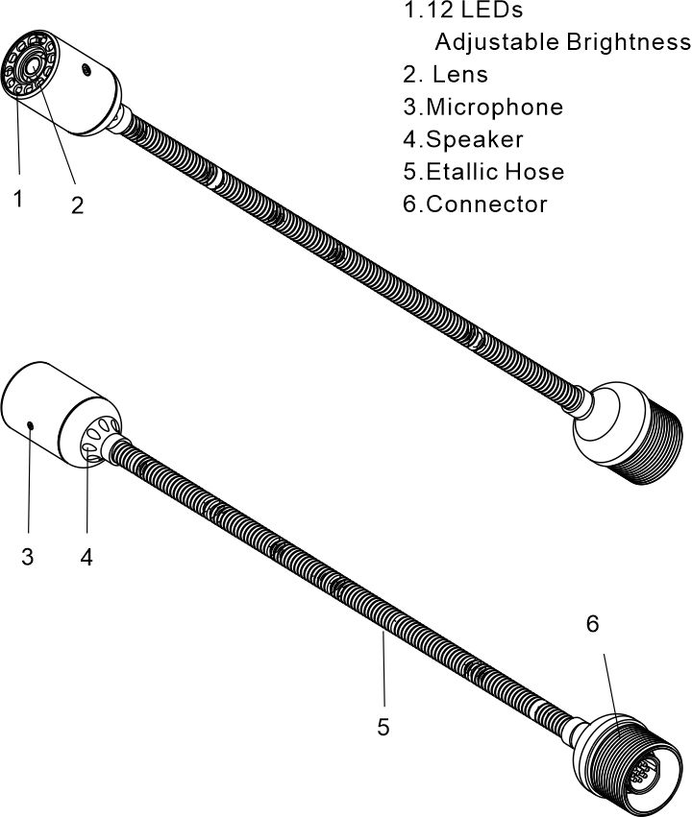

Infrared Thermal Imaging Detector (Optional)

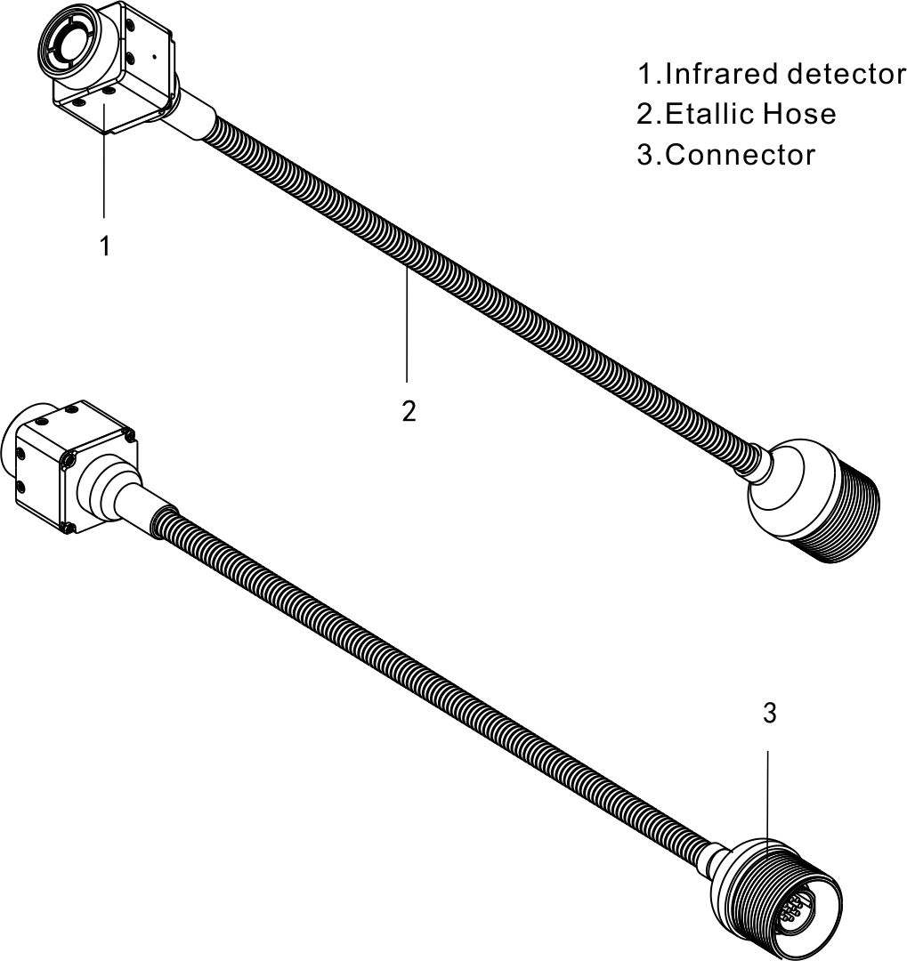

Carbon Fiber Rod

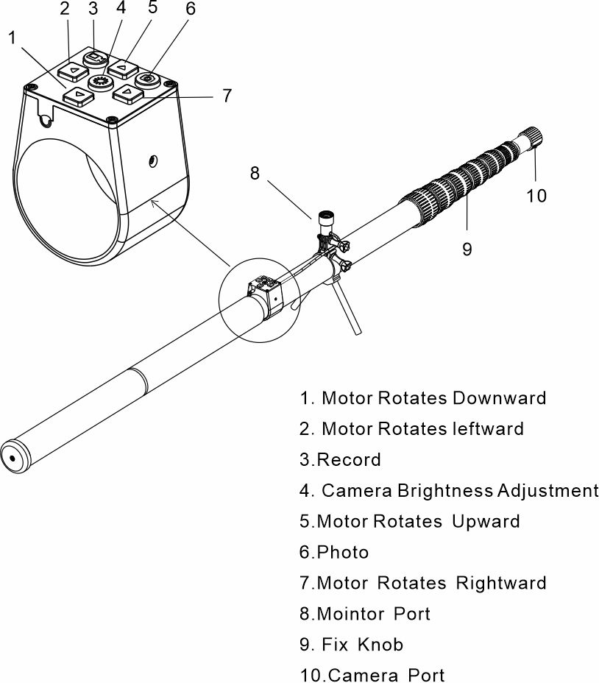

Installation & Use

- 360 ° Audio and Video Life Detector（Optional）
- Audio and Video Life Detector（Optional）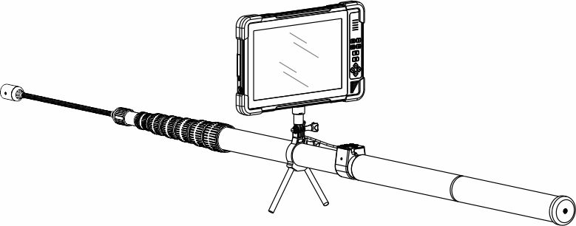
- Infrared Thermal Imaging Life Detector（Optional）
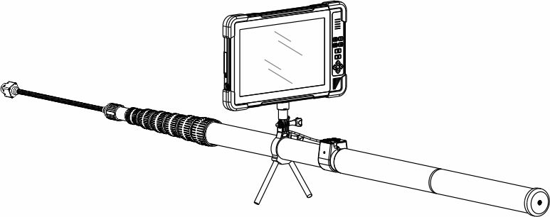

Button Operation

-  ON-OFF
Press briefly to power on. Press it for 3s to power off. If crash, press it for 10s to power off and reset.
-  Photo
Press briefly, flashes once and get a photo.
-  Record
Press briefly to record, and the icon turns blue。The video timer can time. Press again to end.
 Playback/Return
Press it to enter review photos and videos.
Press Up-Down-Left-Right to select.
Press  to confirm. Press Play again to exit
When record, press to pause and stop timing; press again to restore.
-  LED Control
Press it briefly to select On-7 brightness cycle-OFF.
-  Menu/Confirm
Press it briefly to enter. Press Up-Down-Left-Right to select. Press to confirm. Press Play to exit.

Button Operation

- UP
Press to turn camera upward. Release to stop.
- Down
Press to turn camera downward. Release to stop.
- Left
Press to turn camera leftward. Release to stop. Press & hold for 10s to turn camera leftward and into cruise mode. Press any UP-Down-Left-Right to stop.
- Right
Press to turn camera rightward. Release to stop. Press & hold for 10s to turn camera rightward and into cruise mode. Press any UP-Down-Left-Right to stop.

Touch Screen

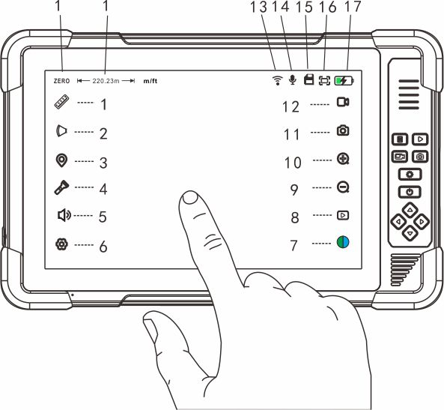

- Range Measurement (Unavailable on this machine)

- Lens Zooming (Unavailable on this machine)

3.Mark
 : Pop up keyboard to input mark, which will display in the lower left corner. Touch it to revise or delete.

Touch Screen
- LED Brightness Control
: Move the slider to control cam’s LED brightness.
- Speaker Volume Control
: Move the slider to control the speaker volume.
- System Setup
: Touch this to enter into system setup.
- Display Parameter Adjustment.
：Move the sliding block to adjust the parameter. ：Brightness  ：Contrast
：Colourity ：Saturation

- Play

: Play photo & video. Touch to lock the important ones in case error deletion. Touch again to unlock it.
- Zoom out
: Touch this to zoom out the screen.
10. Zoom in
：Touch this to zoom in the screen.
- Photo
: Touch to take photo and screen flashes once.

Touch Screen

- Reco
 Touch it, the icon turns blue, and the video timer starts; touch it again to end.
- WiFi
：WiFi is on; if crossed, WiFi is off.
- Mic
： Mic. is on. If crossed, Mic. is off.
- Micro SD card
：Card is ok. If crossed, abnormal or no card.
- Icon Switching of Image Display Scale
Press ：Image displays 4：3
Press ：Image displays 16：9
- Battery power
：Display battery power: the lighting shows it’s charging.

System Setup

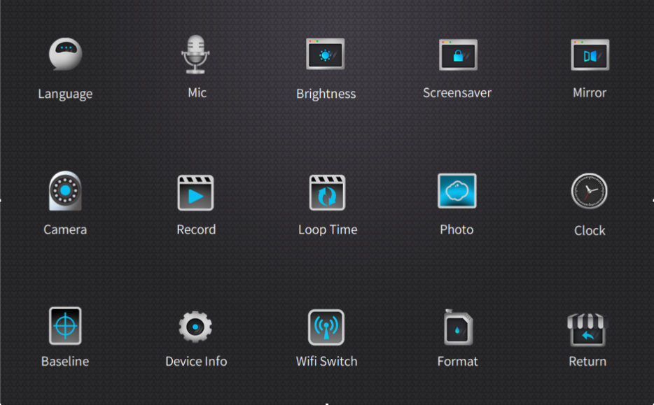

Language Show the available languages: Chinese, Traditional Chinese, English, French, German, Russian, Korean, Japanese.
Mic. Touch to turn the microphone on/off.
Brightness Touch to set the screen brightness.
Screensaver Touch to set the time of screen Saver
Mirror Touch to set: normal display; flip horizontal; flip vertical; flip horizontal & vertical.
Camera Touch to set camera input resolution. According to the resolution & frame rate of the known AHD camera, you can choose: Auto 2K, 1080P, 720P, CVBS. Monitor will reset after switching the resolution.
Record Touch to set resolution of recording.

System Setup

Loop Time Touch to set the time of recycle recording: 1s, 2s, 3s, 5s 10s, off. If choose ‘off’, recording will end until the micro SD card is full.
Photo Touch to set the size of photo: 1.2 mega pixels, 8 mega pixels, 4 mega pixels, 2 mega pixels.
Clock Touch to set the system date & time.
Baseline Touch to set the types of baseline: off; cross; ruler; roundel.
Device Info. About, Reset and Password Switch
About: Includes Wifi name and password, memory size of micro SD card, firmware version.
Reset: It can delete all the settings and restore to factory state and restart.
Password Switch: Switch off, it directly enters working state upon startup; switch on, it needs to enter a password to start working. The default startup password is 8888.
WiFi Switch Touch to switch Wifi on or off.
Format Touch and check format micro SD card. Format will delete all the data in micro SD card. Be sure to do a good job of data backup.
Return Touch it to return and exit system setting.

RoadCam APP

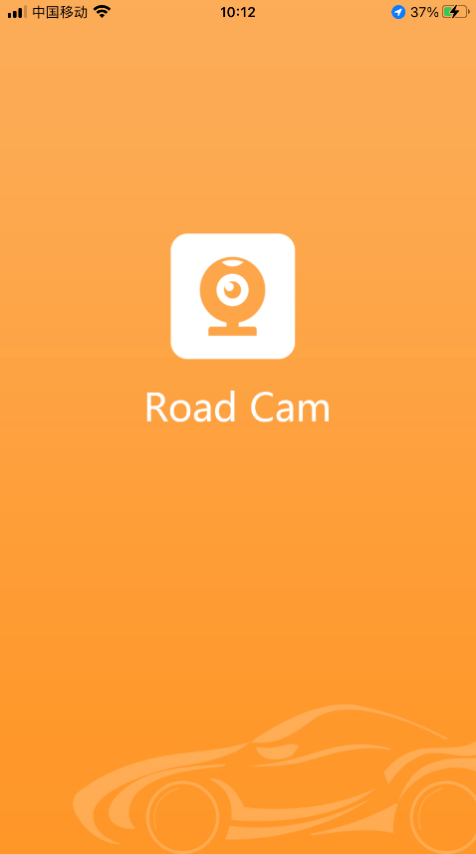

Before run RoadCam App, turn on the Wifi of the monitor first. Find the SSID name and password in “About”. Then add the WiFi network of the monitor to the WiFi configuration of the external device.

APP Monitoring Interface



- Run RoadCam App，touch device to connect. After successful connection, it automatically jump to camera interface. You can take photo, recording, play and share.
- You also can change the WiFi name and password in RoadCam Setting.
- Save the photo and recording files to monitor.
- Enter into Video, play and load video locally.
- Enter into Photo, play and load photo locally.

Charge

Push away the waterproof protective cover. Connect DC12V adapter with DC port, or connect Type-c port with USB-C adapter (user himself provided). During Charging, the indicator is on. When fully charged, the light turns off. It takes about 4 hours to fully charge.

Firmware Upgrade

Before upgrade, please ensure power is >20% (1 grid). Copy upgrade file (SigmatarUpgradeSD) to microSD card. Power on, it will auto upgrade. It will auto turn off after upgrade. Unplug card to finish upgrade.

Attention

- Please use device under temperature between –20 ℃ and 60℃. Excessive temperature will cause abnormal expansion, ignition and even explosion of the battery. Before using it under low temperature, it is recommended to fully charge under normal temperature to extend the life of battery.
- Please place device in a proper position to prevent it from falling and breaking the screen.
- This machine is dustproof and rainproof. Please do not immerse the machine in water.
- If you continue to use the microSD card on this device after upgrade, please delete the upgrade file in the card first。
5. The default startup password is 8888.
Specification

4K Tablet Monitor

Display | 10.1inch
Screen Resolution | 1280*800 pix
Touch screen | capacitive touch screen
Video recording | 4K(16:9): 3840x2160@25 /30fps
Video recording | 2K(4:3): 2560x1944@25 /30fps
Video recording | 2K(16:9): 2560x1440@25 /30fps
Video recording | 1080p(16:9): 1920X1080@25 /30fps
Video format | MP4(H.265)
Photo | 12MP、8MP、4MP、2MP (JPG)
HDMI Output | 1080P
microSD Card | 2GB-256GB(64GB default)
WiFi Protocol | 802.11 a/b
WiFi Operating Freq. | 2.4000-2.4835GHz
WiFi Transmission Power | <16dBm
Battery Capacity | 6200mAh( 45.88Wh)
Power Supply | DC 12V / 2.5A
Working Time | Over 8 hours
Waterproof grade | IP65
Size | L*W*H 30*19*1.8CM
360° Intercom Camera (optional)

Sensor | SONY
Resolution | 5 megapixels（2592 x 1944）
Camera Rotation | 360 ° horizontal circular rotation  180° vertical rotation
Rotation Rate | 12r/min
Light Source | 12 LEDs
FOV | 128.5°
Sight distance | 0.4-5m
MIC | 48dB
Speaker | 1W

Hose Intercom Camera (Optional)

Sensor | SONY
Resolution | 5 megapixels（2592x 1944）
Light Source | 12 LEDs
FOV | 128.5°
Sight distance | 0.4-5m
MIC | 48dB
Speaker | 1W

Infrared thermal imaging camera (Optional)
Detector | uncooled vanadium oxide infrared
Resolution | 256*192
Pixels Spacing | 12μm
Response band | 8～14μm
NETD | ≤50mK@25℃

Carbon Fiber Rod
Unfolded Length | 5.00m
Shrinkage Length | 1.40m
Number of Telescoping Joints | 5

RoadCam App Download


