Thermal infrared imaging video detector
VPC Pole Thermal Camera

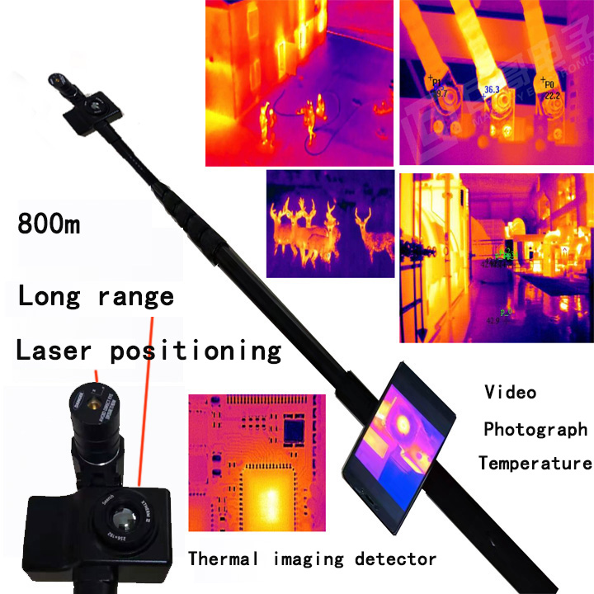

Description:

This VSPVC360TM is a cutting-edge touch intelligent telescopic thermal infrared imaging inspector. This advanced device features a telescopic thermal infrared video detector capable of capturing high-resolution images, recording videos, and measuring temperatures. It also includes a video life detector and an infrared thermal imaging temperature checker.
The camera is designed with a 360-degree retractable hose structure and a wide-angle lens that can be adjusted to any angle, making it highly portable and versatile. The multifunctional high-definition LCD screen, equipped with an Android smart touch interface, enhances user experience by enabling video recording, photography, and temperature detection with clarity and precision.
This high-tech equipment is indispensable in various fields, including security checks, anti-terrorism operations, post-earthquake life searches, epidemic temperature monitoring, and covert surveillance. The camera's integrated thermal infrared light allows for effective use in dark environments or at night, further extending its utility. Its lightweight telescopic tube design ensures ease of transport and deployment.
The VSPVC360TM sets a new standard in thermal technology, offering comprehensive solutions for professional applications requiring reliable and accurate thermal imaging.

Applications:
Anomaly Detection in Elevated and Concealed Areas:
- Inspect high places, vehicles, tables, stools, containers, train cars, collapses, cracks, and hidden objects with ease, ensuring thorough checks in both high and low special occasions.
Earthquake Relief:
- Efficiently detect buried living beings, aiding in life-saving operations during post-earthquake rescue missions.
Transmission Circuit Monitoring:
- Accurately assess the temperature of substations, transmission lines, railway tracks, high-speed rail lines, and other circuits, identifying potential issues at critical nodes.
Temperature Screening:
- Conduct non-contact body temperature checks at the entrances and exits of subways, stations, ports, docks, prisons, hospitals, schools, and other facilities. Quickly screen individuals with fever, facilitating further medical examination and control measures.
Anti-Terrorism Operations:
- Utilize the telescopic structure to discreetly observe indoor environments through windows and other openings. Capture real-time images and videos in poorly lit areas, enhancing situational awareness and intelligence gathering.
Security Inspections:
- Detect and inspect concealed electronic devices, such as cameras and recording equipment, ensuring comprehensive security checks in various scenarios.
Floor Heating System Inspection:
- Efficiently locate and identify leaks in floor heating water pipes, ensuring timely maintenance and repair.
These applications highlight the versatility and advanced capabilities of the VSPVC360TM, making it an indispensable tool for professionals in various fields. Whether it's ensuring safety, conducting rescue operations, or performing routine inspections, the VSPVC360TM delivers unparalleled performance and reliability.
Product Features:
High-Definition Touch Monitor:
- Delivers clear and intuitive inspection images, ensuring precise and detailed visual feedback.
360-Degree Bendable Hose Camera:
- Offers flexible and comprehensive viewing angles, eliminating blind spots and enhancing search efficiency.
Rapid Temperature Measurement:
- Accurately measures body temperature of individuals within a 5-meter range in just 0.1 seconds, ensuring swift and reliable screening.
Precise Temperature Detection:
- Allows users to click on the screen to obtain the temperature at any specific point, providing detailed thermal analysis.
Premium Portable Carrying Case:
- Facilitates easy transport, storage, and maintenance of the product, ensuring durability and convenience.
Infrared Laser Pointer:
- Enhances targeting precision, aiding in accurate and effective inspections.
The VSPVC360TM combines cutting-edge technology with user-friendly features, making it an essential tool for professionals requiring reliable and detailed thermal imaging and inspection capabilities.
Telescopic Rod Features:
- 4-Section Telescopic Rod:
Equipped with a universal serpentine hose, extending to a total length of 2.0 meters.
- Premium Construction:
Made from high-grade, ultra-light aviation aluminum with a polished surface and hard anodizing for enhanced durability.
- Superior Material Properties:
Features low density, light weight, high strength, and exceptional resistance to corrosion, low temperatures, and wear.
- Ergonomic Non-Slip Handle:
Designed for a natural grip, providing anti-slip and anti-aging benefits for comfortable and secure use.
- Triangular Fixing Bracket:
Ensures stability and reliability during operation.
Camera Features:
- Infrared Image Resolution: 256*192
- Pixel Size: 12µm
- Response Band: 8-14µm
- Focus Adjustment: Manual focus adjustment for clear images (suitable for both macro and long-distance detection)
- Detector Type: Uncooled IR Focal Plane Detection
- Fast Imaging: 0.1 second adaptive imaging, no tailing in red-head mode
- Lens Focal Length: 9mm lens combined with 12µm thermal imaging core
- Field of View: 19.6° x 14.7°
- Laser Positioning: High-speed laser indication and hot spot tracking
- Noise Equivalent Temperature Difference: ≤60mK
- Image Frame Rate: 25Hz
- Temperature Testing Range: 0°C to +80°C
- Temperature Measurement Accuracy: ±3°C
- Temperature Detection: Max/Min/Center
- Temperature Measurement Method: Point tracking for high and low temperature measurement
- Temperature Correction: Manual/automatic
- Temperature Output: Real-time parallel output
- Image Enhancement: Multi-level detail enhancement
- Image Correction: Shutter correction
- Color Palette: White hot, black hot, rainbow, iron red, iron gray, and other pseudo-color palettes
- Video Recording/Photo: Supported
- Operating Temperature: -10°C to 50°C
- Storage Temperature: -20°C to 60°C
- Power Supply: 3.8-5.5V DC
- Required System: Android 6.0 or higher enabled device
- Ultra-Long Detection Imaging Distance: Clear imaging up to 870 meters
Smart Display Touch Screen:
- Weight: Handheld smart display body weight = 165g
- Battery: Built-in lithium battery
- Camera: Built-in rear camera, 13 MP
- Picture-in-Picture: Supports thermal infrared images and rear camera images in picture-in-picture mode
- Stabilization: Optical image stabilization supported
- Selfie Camera: On-site selfie camera, 5 MP
- Display Resolution: ≥1920*1080 (FHD)
- Input Method: Touch
- Memory: Micro SD Card (not included)
- Maximum Storage Expansion: Up to 128 GB
- Interface: USB
- Wireless Sharing: WIFI networking, direct video sharing, APP installation for video sharing and transmission
- Headphone Jack: 3.5mm port
- Volume Switch: Touch volume switch for adjusting the volume level
- Compass: Image supports compass function
- Picture-in-Picture: Images support picture-in-picture
- Location: Supports location positioning
- Time: Time display supported
- Weather: Weather display supported
- Screen Recording: Supports screen recording mode
- System Camera: Supports dual image display of system camera
- Language: Simplified Chinese / English / Japanese / Traditional Chinese / French / German / Spanish / Italian / Portuguese / Russian
- Length: 535mm (shortest after shrinkage); 1560mm (maximum elongation, subject to actual conditions)
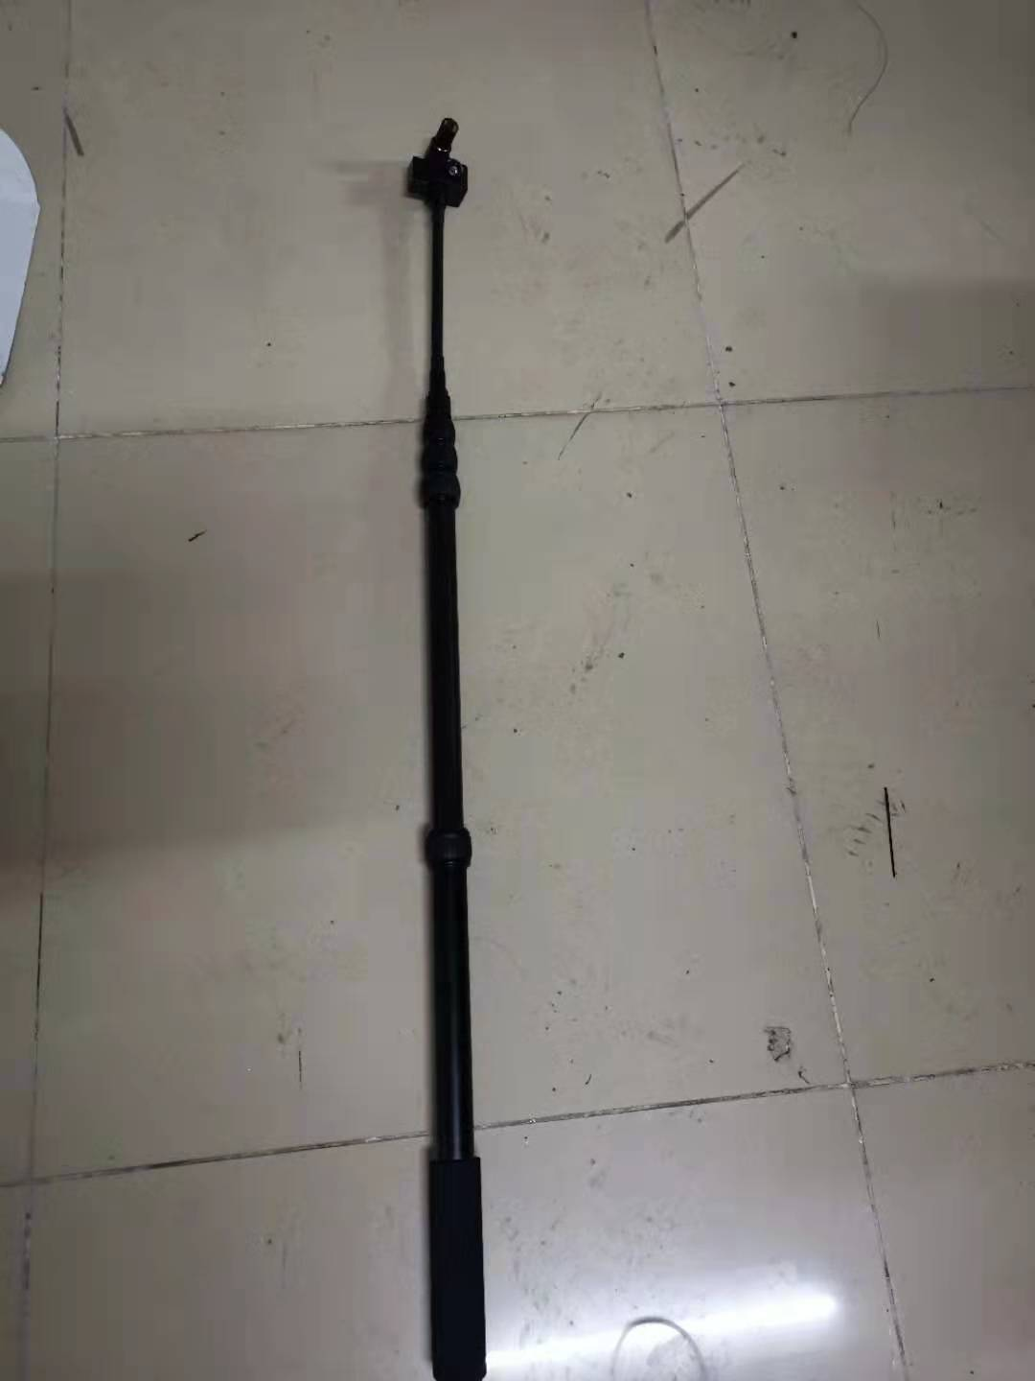
Introducing the VSPVC360TM, the ultimate in professional inspection technology. This advanced telescopic thermal infrared imaging device captures high-resolution images, records videos, and measures temperatures with precision. Its 360-degree retractable hose and adjustable wide-angle lens offer unmatched flexibility and portability. The high-definition LCD screen with an Android smart touch interface provides seamless video recording, photography, and temperature detection.
Ideal for security checks, anti-terrorism operations, earthquake rescues, temperature monitoring, and covert surveillance, the VSPVC360TM's integrated thermal infrared light ensures effectiveness in dark environments. Combining cutting-edge technology with user-friendly features, this indispensable tool sets a new standard in thermal imaging, delivering unparalleled performance and reliability for professionals.

