Precautions  To protect you and others from harm or to protect your device from damage,  Please read the following information before using your device.  1. Do not look the product directly at the sun and other high-intensity radiation sources;  2. Do not touch or collide with other objects with the imager window and lens;  3. Do not touch the device and USB port with wet hands;  5. Do not scrub your device with thinner;  6. Please pay attention to prevent static electricity;  7. Do not disassemble the equipment, if there is a fault, please contact the company, and the professional will repair it.  Product Overview  2.1 Application scenarios  To use VSPVC360TM intelligent thermal infrared imager, you need to download and install intelligent terminals  Thermal infrared imager Android intelligent terminal software, through which infrared is realized  Detection inspection and infrared imaging functions. The best imaging distance is fixed-point imaging within 1.5 meters.  2.2 Main Functions  The main functions are as follows:  (1) Open the application software of the infrared thermal imaging camera to realize infrared thermal imaging;  (2) Infrared imaging and temperature analysis;  (3) Take photos and videos;  (4) Action control and parameter setting of thermal infrared imager. |  | Technical parameters  Resolution: 256×192  Cell size: 12μm  Response bands: 8~14μm  Lens focal length: 9.0mm  Field of view: 19.6°×14.7°  Focusing method: Manual  Image frame rate: 25Hz  NETD ≤50mk  MRTD ≤500mK  Operating temperature: -10℃~+ 50℃  power consumption: < 350mW  Support system: Android 6.0 and above*  Image enhancement: Digital detail enhancements  Crosshairs: Division, high and low temperature tracking  Swatches Multiple pseudo-color slabs such as white hot, black hot, red head, et  Zoom Support : 1x~4x continuous digital zoom  Video saving: Support photo and video saving functions  Storage temperature range: -20°C to 60 °C  Interface type: USB  Power Supply：3.8 ~ 5.5V DC
  3. Software APP icon  4. Product use  4.1 Device Connection  Insert the thermal imaging camera into the USB socket of the smart terminal, the smart terminal will automatically recognize the USB device and pop up a prompt, click "OK", the software will start the thermal infrared detector, and the screen of the smart terminal will enter the infrared thermal imaging screen.  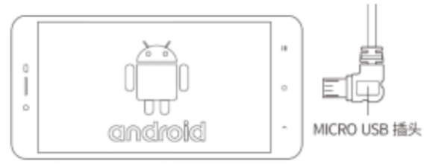  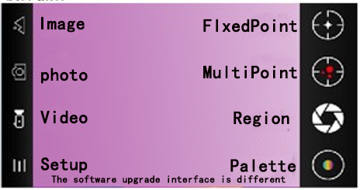  1) Gallery: Click to view the photos and videos stored in the gallery of the smart terminal.  2) Take a photo: Save the current picture, and the photo location is: Internal Storage/DCIM.  3) Recording: Click to start recording, click to end recording again, and the recording position is: internal storage/DCIM.  Color palette: choose a different display mode; Such as iron red, white hot  Special reminder  When the thermal imaging checker is taken out from a place where the temperature of the environment to be measured is large, the imager should be placed in the environment to be measured for 20 minutes before use. |  | Thermal infrared imaging detector system  VSPVC360TM User Manual  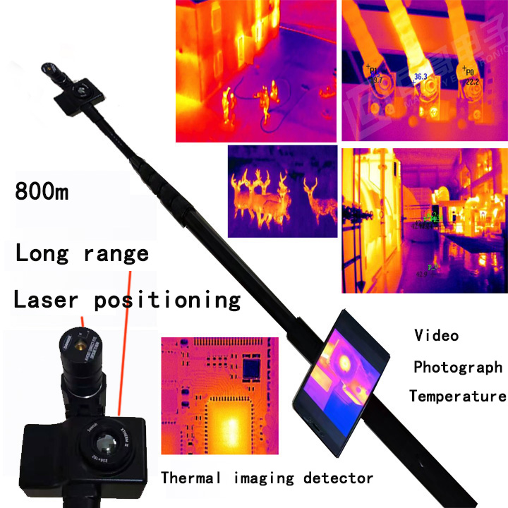  Please read the instructions carefully before use and store them properly  The software upgrade interface is different！

